**Creating a New Digital Signature using Adobe Reader**

1. Ensure you’ve downloaded the most recent version of Adobe Reader to your computer as guided on the ACOS Education Website:

**https://get.adobe.com/reader/**

1. Open the Affiliation agreement with **Adobe Acrobat Reader** and click on the signature block and this box will appear. **Click on “new digital ID…” and then “next”**

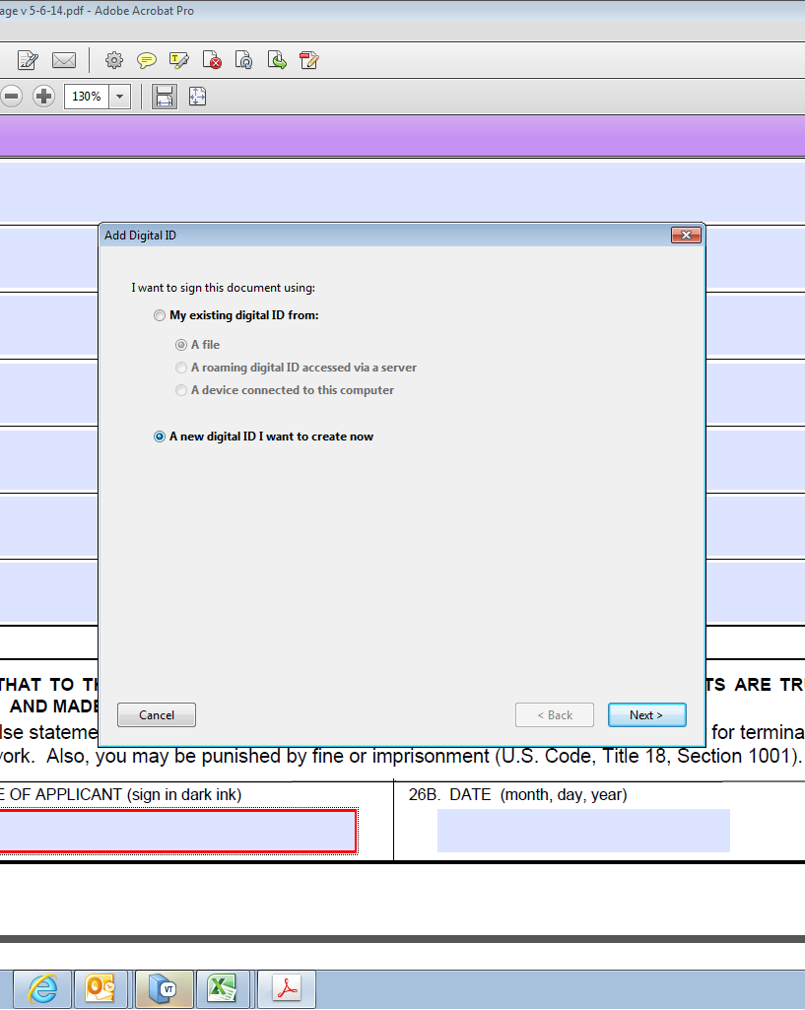

1. Click on “Windows Certificate Store” and Next

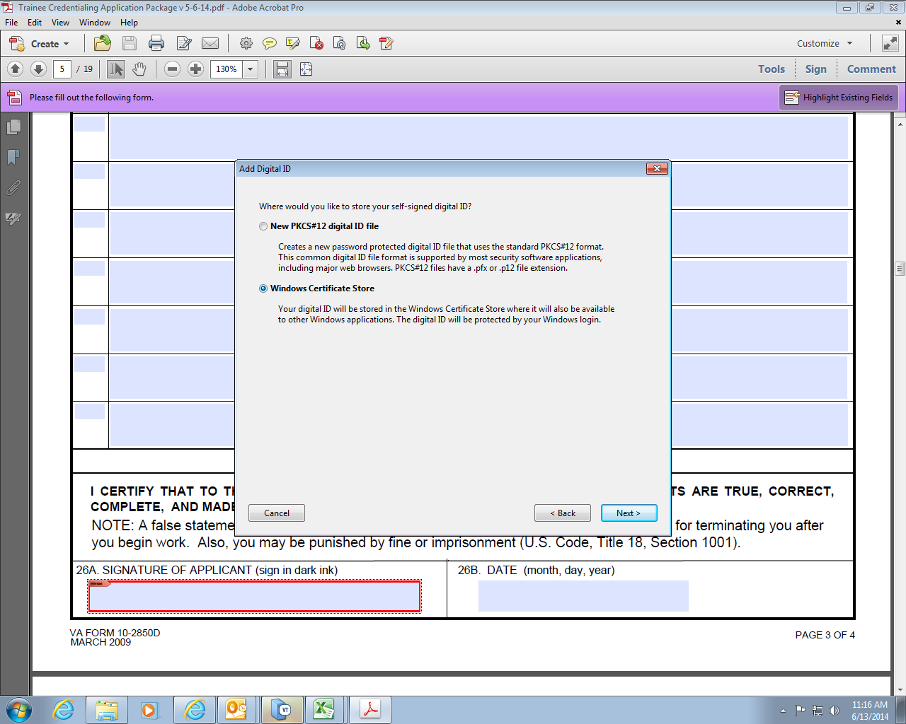

1. **Enter your name and email address and then “finish”.**

